August 22, 2022. Assessment

Question 1

The Fibonacci sequence is defined by the following rule. The first 2 values in the sequence are 1, 1. Every subsequent value is the sum of the 2 values preceding it. Write a Java program that uses both recursive and nonrecursive functions to print the nth value of the Fibonacci sequence?

import java.util.Scanner;

public class Question1Fibonacci {

    public static int fibRecur(int n) {

        if (n == 0) {

            return 0;

        }

        if (n == 1 || n == 2) {

            return 1;

        }

        return fibRecur(n - 2) + fibRecur(n - 1);

    }

    public static void fibIter(int number) {

        int previousNumber = 0;

        int nextNumber = 1;

        for (int i = 1; i <= number; i++) {

            System.out.print(previousNumber + " ");

            int sum = previousNumber + nextNumber;

            previousNumber = nextNumber;

            nextNumber = sum;

        }

    }

    public static void main(String[] args) {

        Scanner input = new Scanner(System.in);

        System.out.print("Enter a number: ");

        int n = input.nextInt();

        System.out.println("Fibonacci series up to " + n + "th number:");

        System.out.print("Recursive: ");

        for (int i = 1; i <= n; ++i) {

            System.out.print(fibRecur(i) + " ");

        }

        System.out.print("\nIterative: ");

        fibIter(n);

        input.close();

    }

}

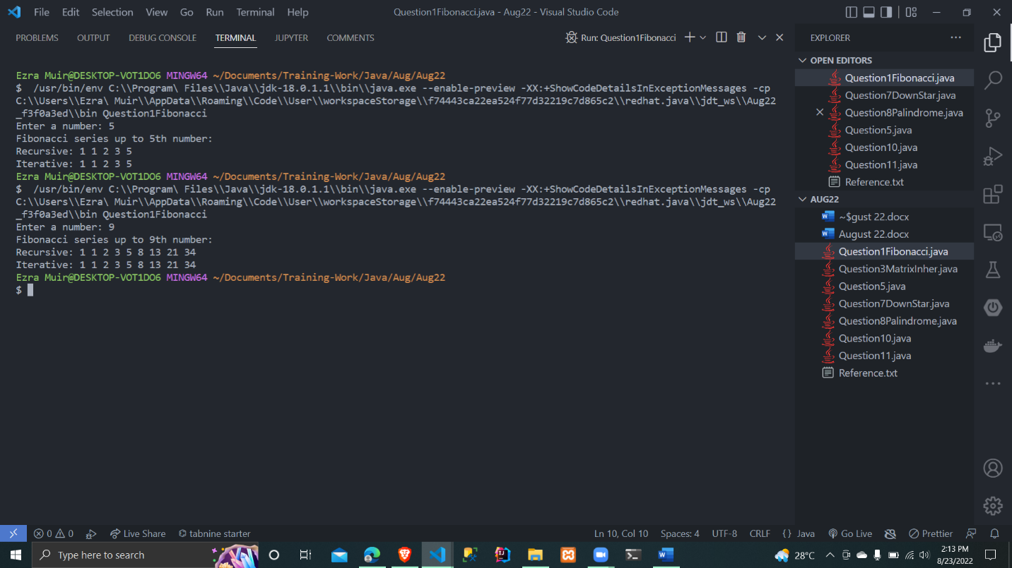

Question 7

Write a code for following pattern Downward Triangle Star Pattern

\* \* \* \* \*

\* \* \* \*

\* \* \*

\* \*

\*

public class Question7DownStar {

    public static void main(String[] args) {

        int i, j, starRow = 5;

        for (i = starRow; i > 0; i--) {

            for (j = 0; j < i; j++) {

                System.out.print("\*" + " ");

            }

            System.out.println();

        }

    }

}

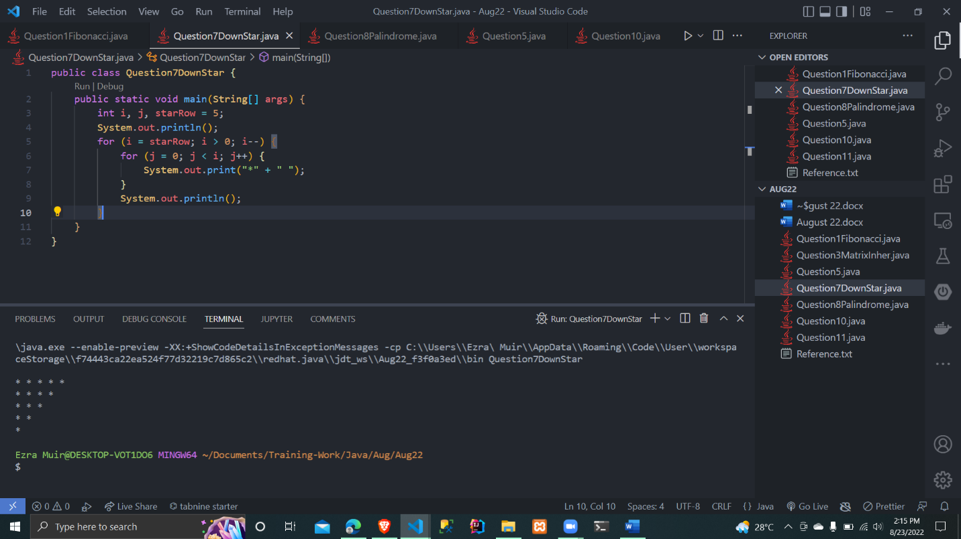

Question 8

Take number from the user, reverse it and add it to itself. If the sum is not a palindrome then repeat the procedure until you get a palindrome. For example, If 7325 is input number, then 7325 (Input Number) + 5237 (Reverse Of Input Number) = 12562 12562 + 26521 = 39083 39083 + 38093 = 77176 77176 + 67177 = 144353 144353 + 353441 = 497794 (Palindrome) In this particular case, we got a palindrome (497794) after 5th addition. This method gives palindrome in few steps for almost all of the integers. Note : Palindrome number is a number which remains the same when its digits are reversed. For example, 121, 7227, 45654.

import java.util.Scanner;

public class Question8Palindrome {

    // method to reversed a number

    int reversedNum(int number) {

        // reverse number

        int reverse = 0;

        while (number > 0) {

            reverse = reverse \* 10 + number % 10;

            number = number / 10;

        }

        return reverse;

    }

    // method to check if reversed num is equal to sum of number

    boolean checkPalindrome(int number) {

        return (reversedNum(number) == number);

    }

    void add(int number) {

        int reverse = 0;

        while (number > 0 && number <= 999999999) {

            reverse = reversedNum(number);

            number += reverse;

            if (checkPalindrome(number)) {

                System.out.println(number + " is Palindrome");

                break;

            }

            // else {

            // System.out.println(number + " is not Palindrome");

            // }

        }

    }

    public static void main(String[] args) {

        // scan number from

        System.out.print("Enter Number: ");

        Scanner input = new Scanner(System.in);

        int number = input.nextInt();

        Question8Palindrome pal = new Question8Palindrome();

        pal.add(number);

        input.close();

    }

}

